Project Design Phase
Solution Architecture

Date | 30 June 2026
Team ID
Project Name | Darshan ease
Maximum Marks | 4 Marks

Solution Architecture:
The DARSHAN EASE solution architecture provides a scalable, secure, and user-friendly web-based platform that connects devotees and temple administrators through a centralized temple darshan ticket booking system. The architecture follows a three-tier architecture consisting of the Presentation Layer, Application Layer, and Database Layer, ensuring efficient communication, secure data management, and high system performance.
The main objectives of the architecture are:
- Provide a secure online temple darshan booking platform for devotees.
- Enable role-based access for Devotees and Temple Administrators.
- Manage authentication and authorization using JWT (JSON Web Tokens).
- Store temple information, darshan slots, bookings, payments, tickets, and user details securely in MongoDB.
- Provide RESTful APIs for seamless communication between the React frontend and the Node.js/Express backend.
- Support real-time darshan slot availability, online ticket booking, secure payment integration, and digital QR-code ticket generation.
- Provide an Admin Dashboard to manage temples, darshan schedules, bookings, and devotee information efficiently.
- Support scalable deployment and future enhancements, such as AI-based crowd prediction, mobile applications, multilingual support, SMS/email notifications, and analytics for temple management.
This version matches the style and structure of your House Rent document while being fully customized for your DARSHAN EASE – Temple Darshan Ticket Booking System.

Example - Solution Architecture Diagram:

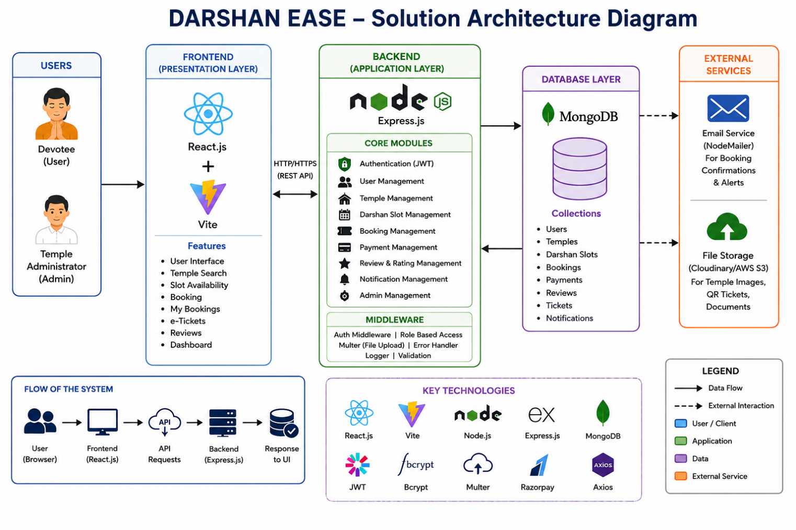
Figure 1: Architecture and data flow of the house rent application

